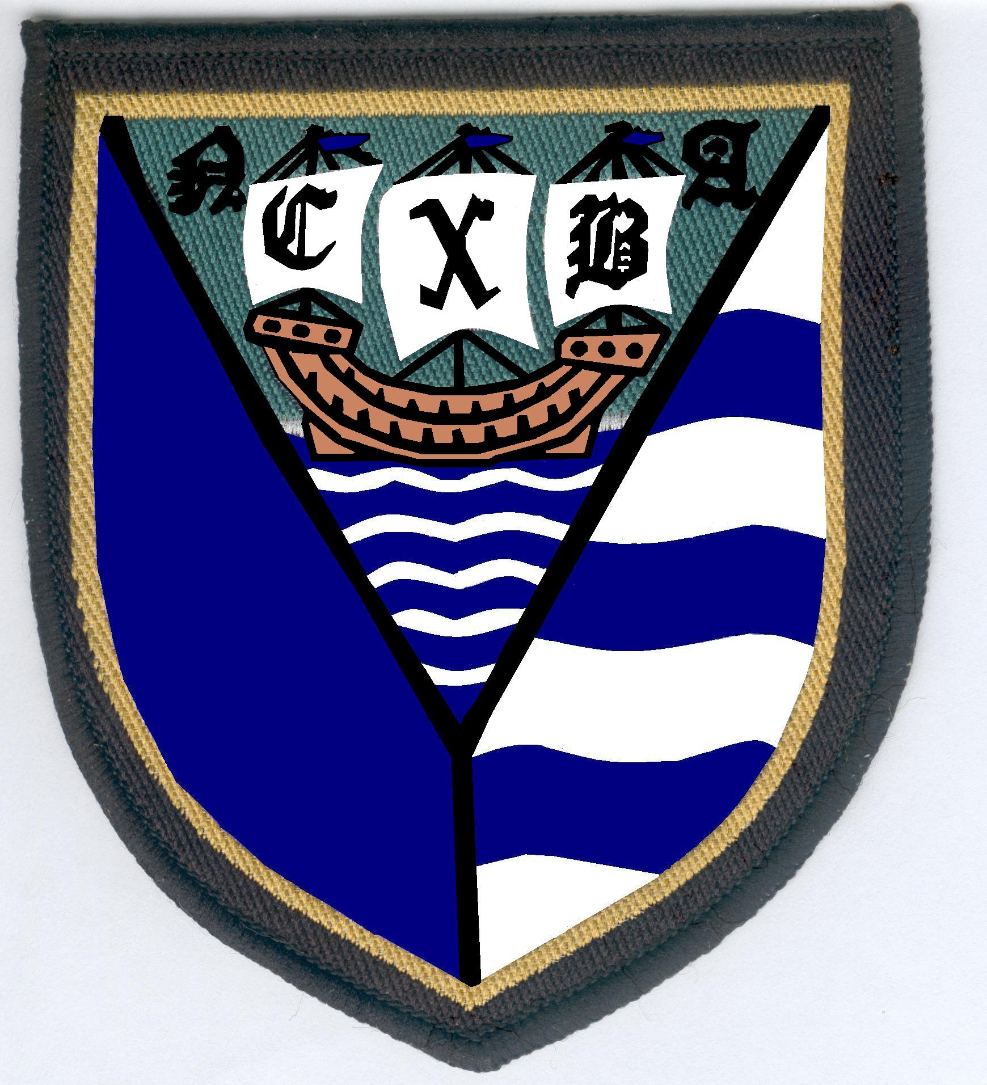
NORTH CAMBS BA OUTDOOR TROPHIES

2 bowl singles | 4 bowl singles
2 bowl senior pairs | 2 bowl mixed pairs
2 bowl pairs
2 bowl senior singles | Secretaries
2 bowl rinks | 2 bowl mixed rinks
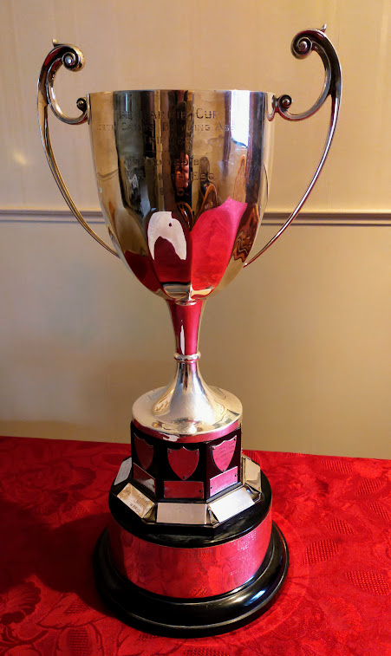

3 bowl rinks | 2 bowl senior mixed pairs
U25 singles | U25 singles runner up
Champion of Champions | County Challenge Cup
U25 singles | U25 pairs

